3. Larger Switch Networks
Using simulation mode, analyze the network behavior and the format of an Ethernet frame by
sending the following frames. Identify the switches’ behavior and their forwarding tables.
- From PC1 to PC7.

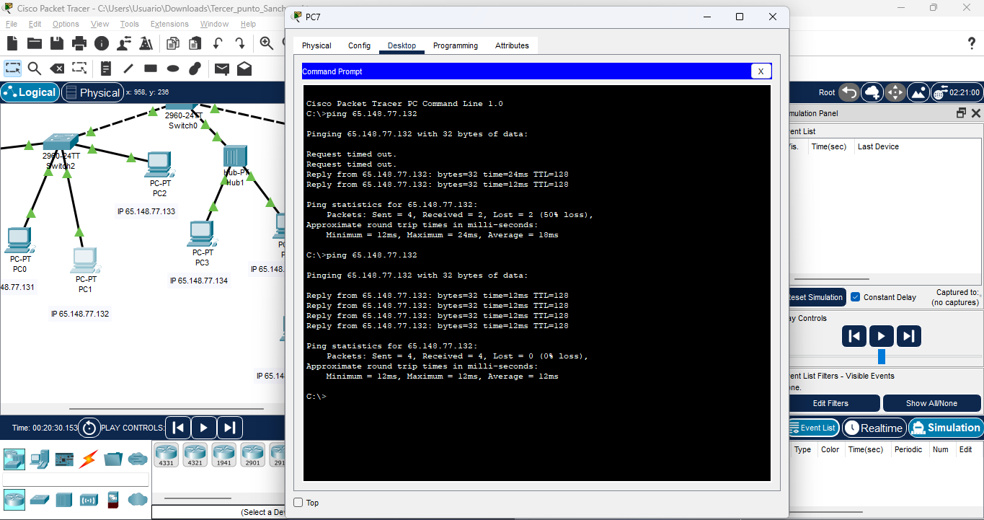
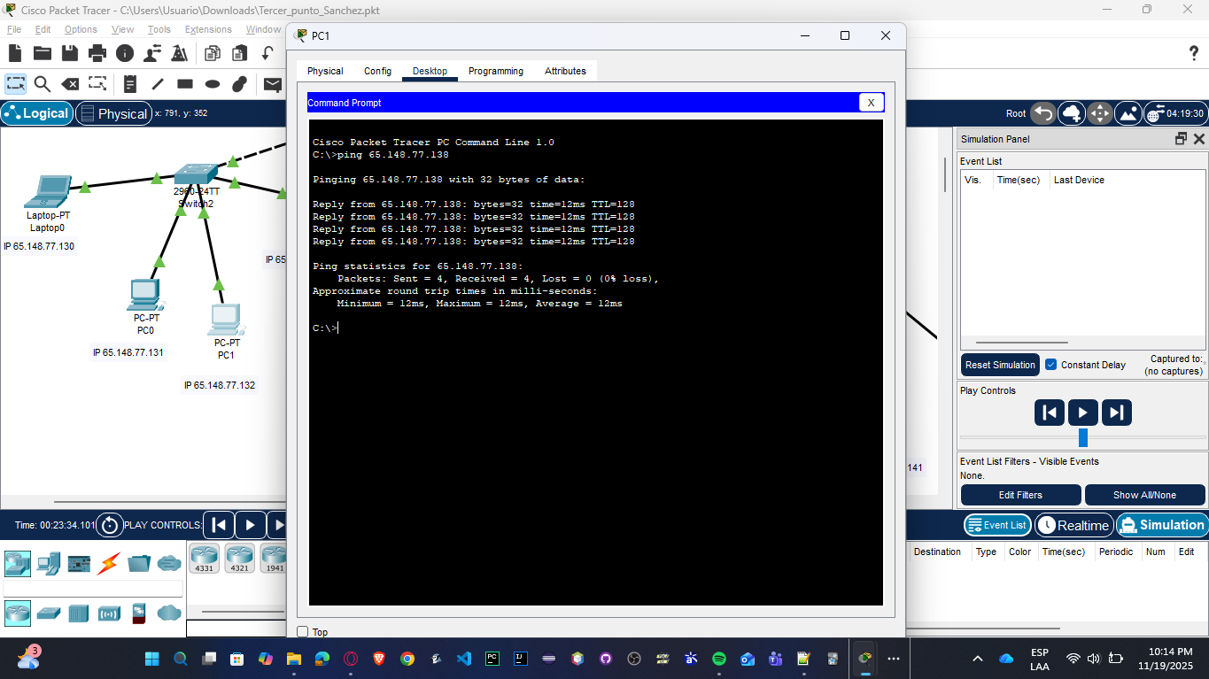

- From PC0 to PC9.
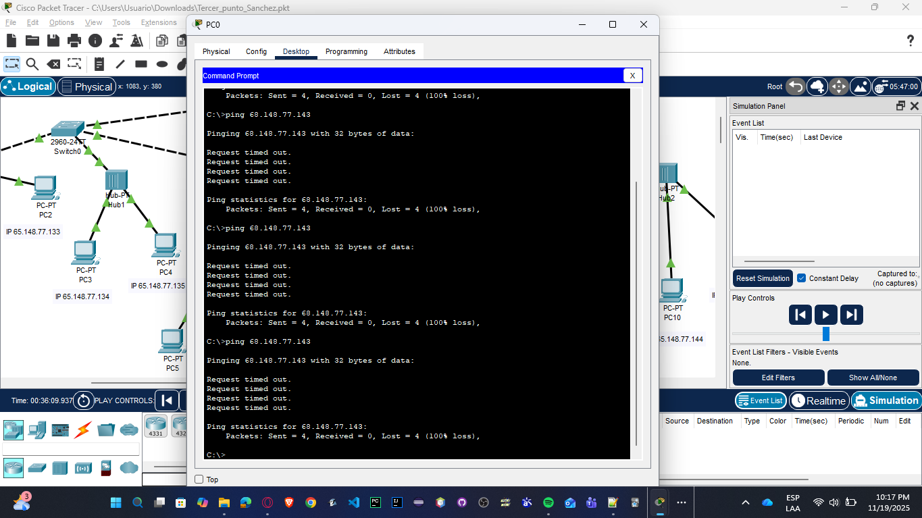

- From Server0 to Server1.

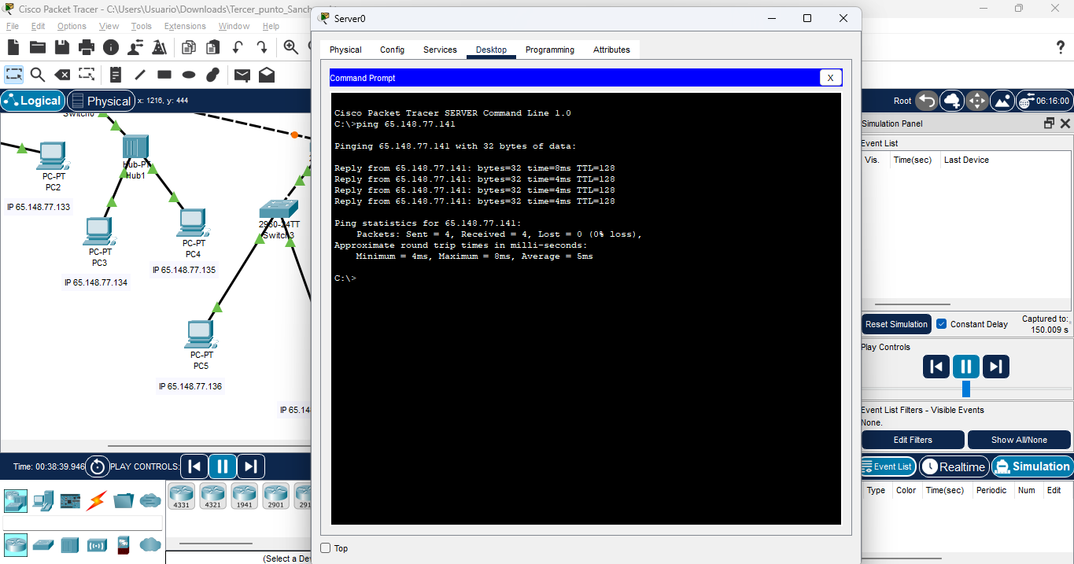

- From Laptop0 to Laptop1.
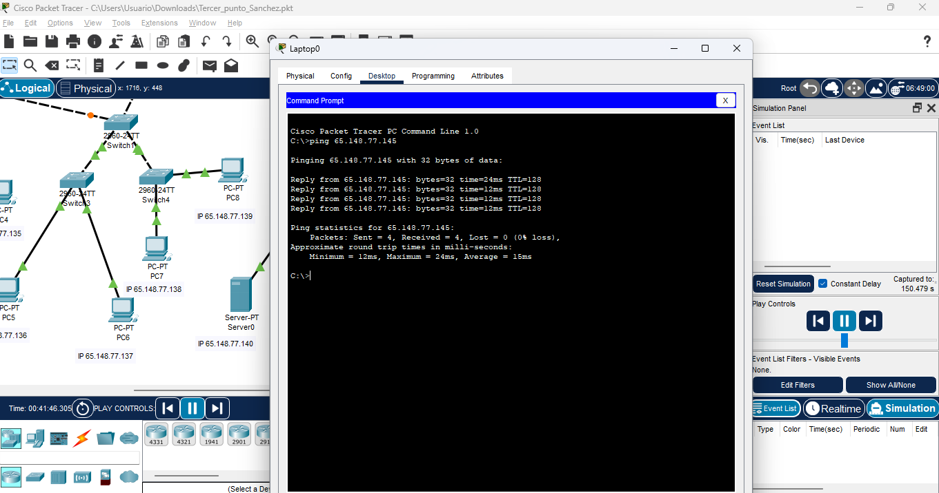

5. Basic WiFi Configuration

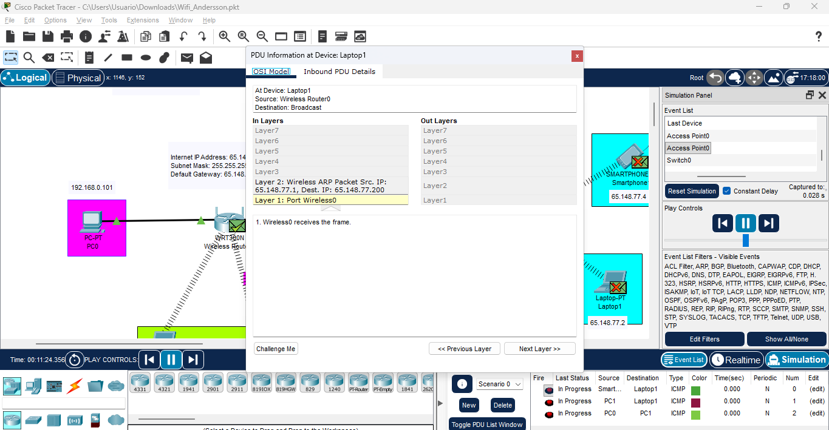

1. Tabla ARP:

Desde la CLI de cualquier dispositivo, revisa la tabla ARP con arp -a
Deberías ver las direcciones MAC de los dispositivos con los que te has comunicado

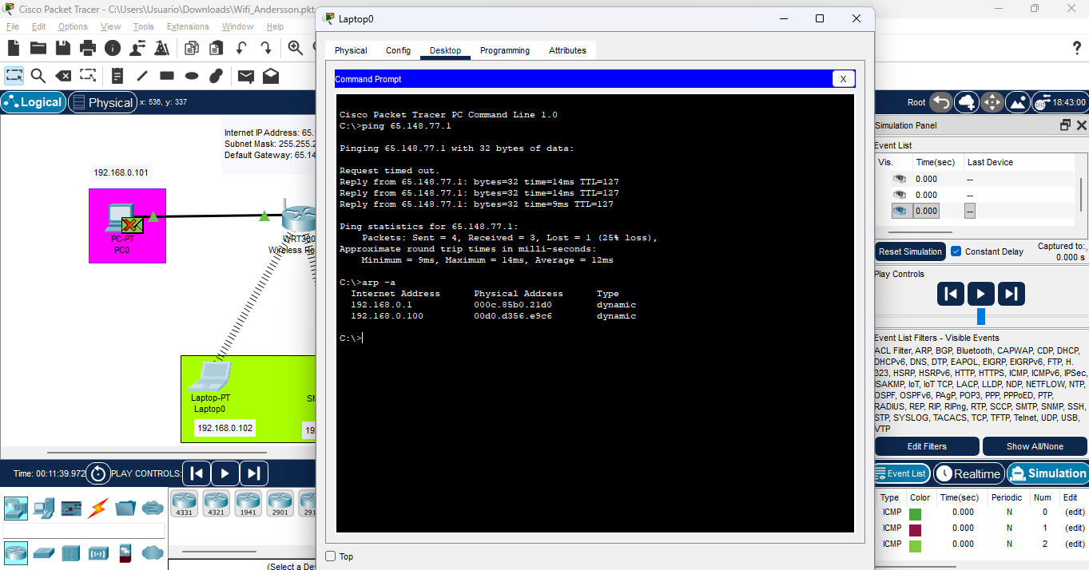

6. Configuration of Wired and Wireless LAN

PC2 to PC5: 171.18.110.58
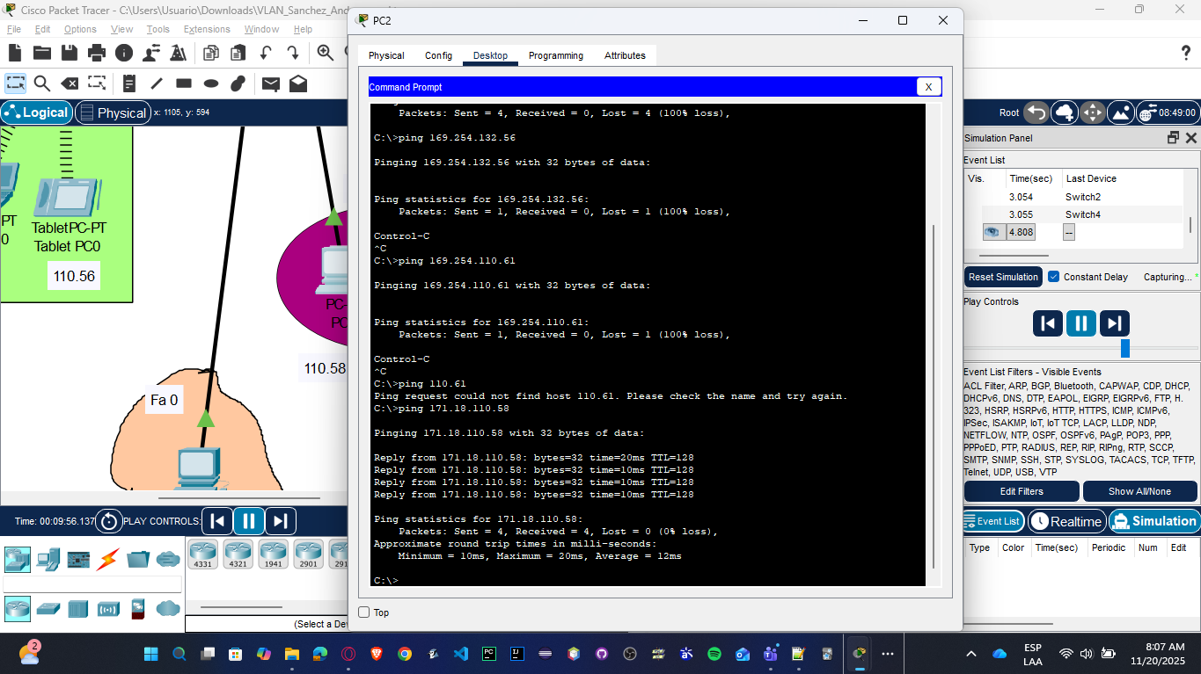
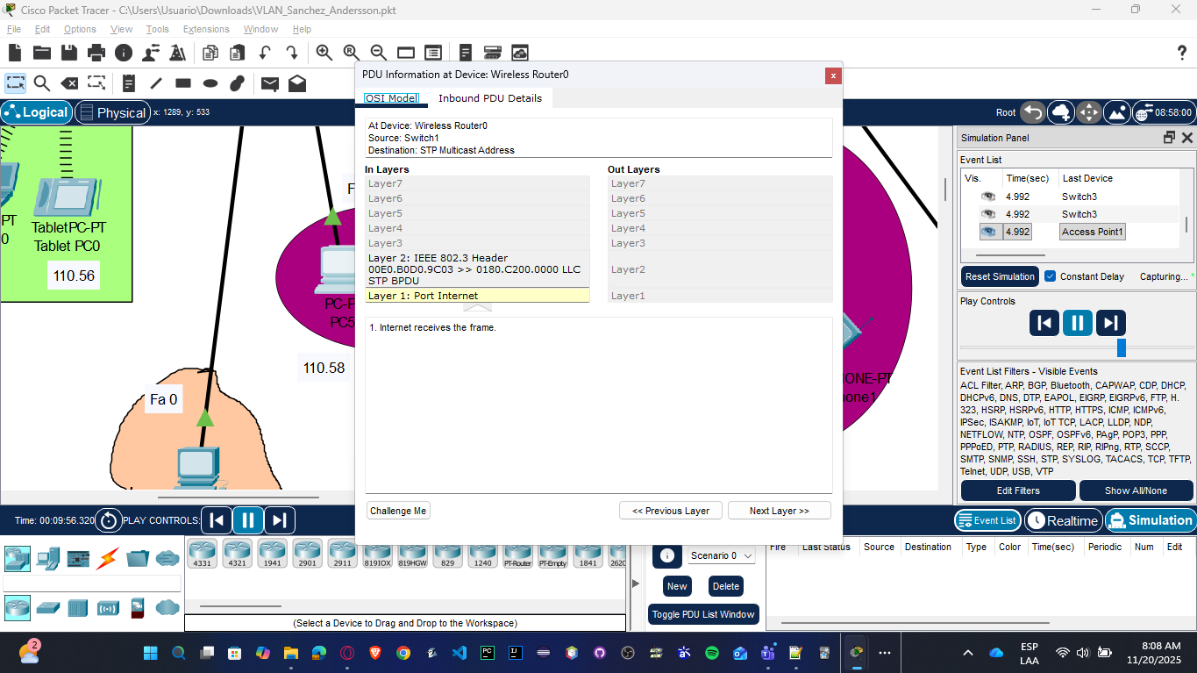

Laptop0 to 192.168.0.1:
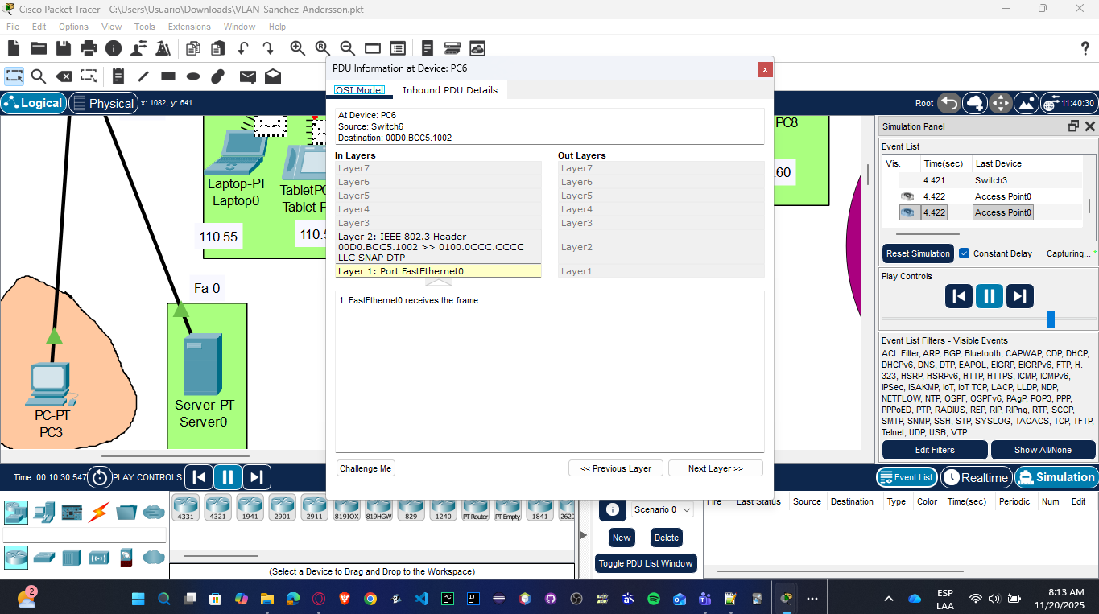

Smartphone0 to PC6: 171.18.110.59
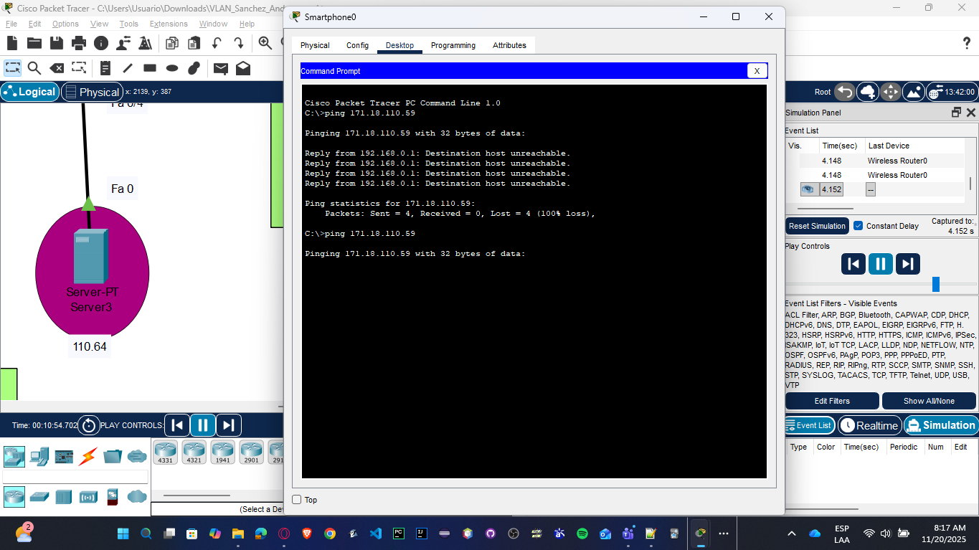

En los switches:
show vlan brief // Muestra las VLANs configuradas

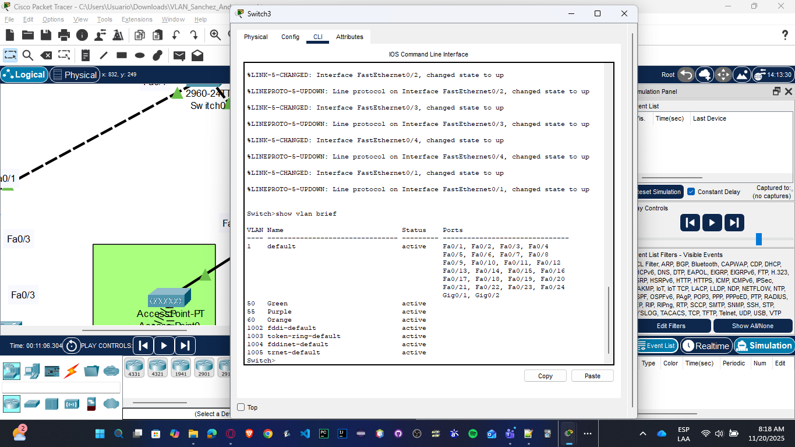
show mac address-table // Muestra las MACs aprendidas
